**Detailed Projections for Profit and Loss Over the First Three Years of Operation**

**Framework:**

**Factors to consider:**

* **Expenses:** 
  + Development Expenses: These comprise database building, website development, app development (if appropriate), and continuing maintenance.
  + Operational Costs: Take into account costs for marketing, customer service, data storage, server fees, payment processing fees, and any employee compensation.
* **Market Share and Approach to Pricing:**
  + Market Analysis: Determine the target market size and current competitors for calorie-tracking websites in your area.
  + Pricing Methodology: Will you provide a freemium model with limited functionality and premium tiers with more features? Think about providing tiers for monthly or yearly subscriptions.
  + Market Share Hypotheses: Regarding the increase in your anticipated user base throughout the first three years, be realistic. Think about estimating conservatively at first and making adjustments as you gather momentum.

**Building Our Projections on the Calorie Tracker Website:**

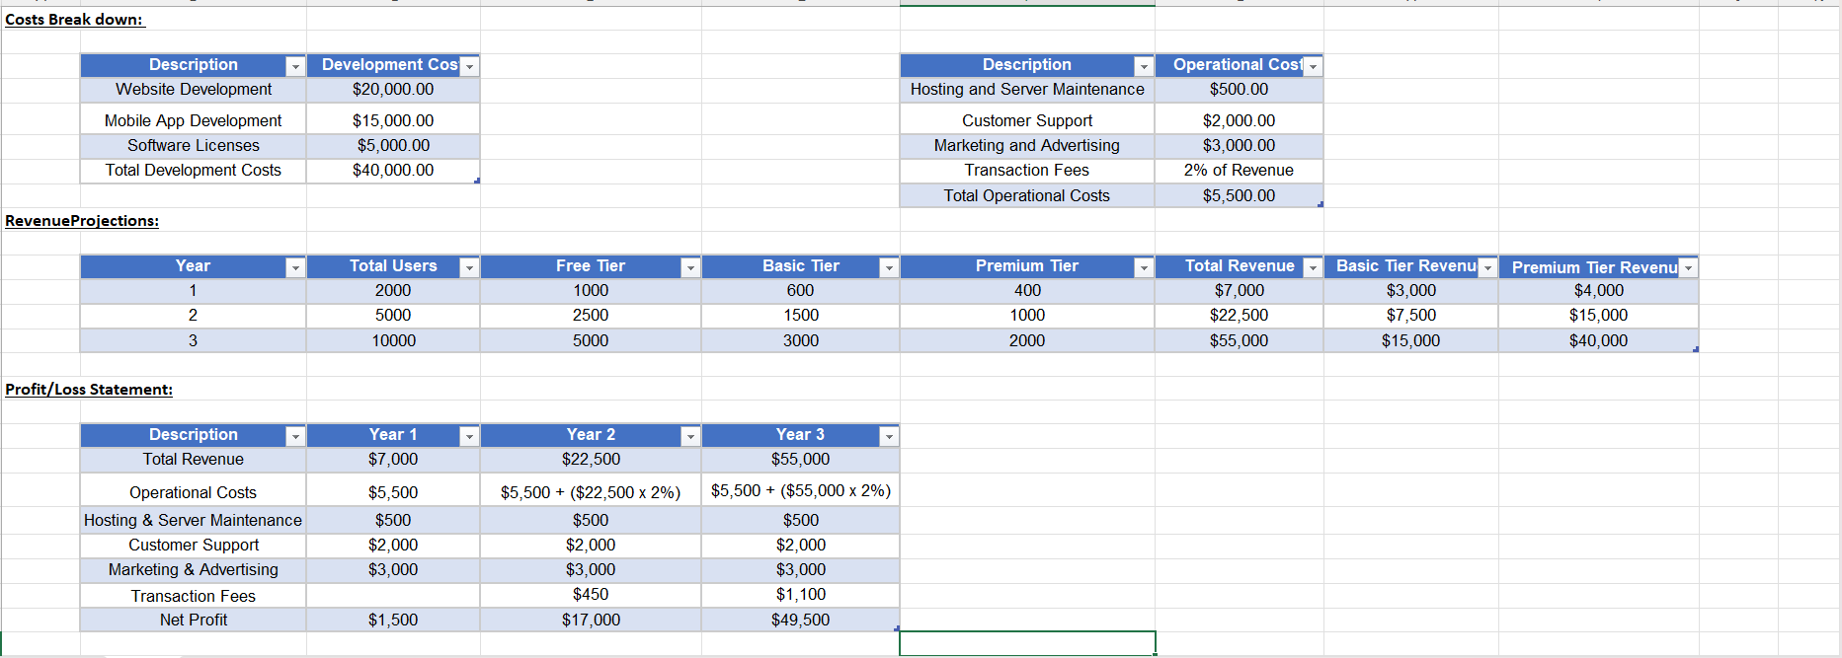

Based on estimates for operating expenses and revenue generation, the aforementioned figure presents a graphical depiction of the expected profit and loss over three years.[Projections for profits and losses. Xlsx](https://docs.google.com/spreadsheets/d/1FwDZdsp9NrYZFy0-4G-wa0ekf12wnhKv/edit#gid=1780141465)

**Break Even Analysis:**

The break-even point is the point at which the cumulative profits equal the initial investment in product development.  
Hence, the cumulative profits are to be determined

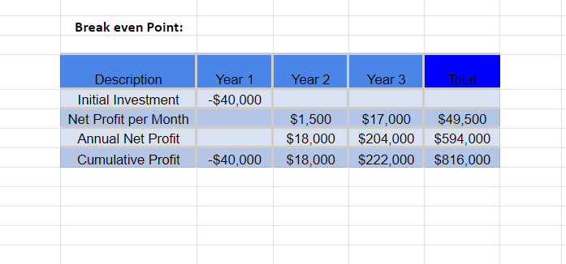

Based on estimates for operating expenses and revenue generation, the cumulative profits are determined, which are shown in the above pictorial representation.

[Projections for profits and losses and Break even point. Xlsx](https://docs.google.com/spreadsheets/d/1OEcCw6UG90R6PqkbQRpUCWu_QUtXou0W/edit#gid=1362483313)

**Break Even Point Calculation:**

In the "Cumulative Profit" column, the first year is found where the value becomes positive. This indicates a profit after the initial investment. (Year 2: $18,000)

Since the break-even point falls between years, the additional months that are required in Year 2 to reach $40,000 (initial investment) are calculated.

Difference to Break-Even: $40,000 - $18,000 = $22,000

Profit per Month in Year 2: $17,000

Months to Break Even in Year 2: $22,000 / $17,000/month ≈ 1.29 months (rounded to the nearest month)

Result: The break-even point is reached in Year 2, Month 7.

**Break-Even Point Analysis - Pictorial Representation:**

This is a simple illustration of the break-even point:

Y-axis: Money ($USD)

X-axis: Time (Months)

* A horizontal line represents the **Initial Investment** ($40,000)
* A stepped line represents the **Cumulative Profit** (Year 1, Year 2, and year 3)

The point where the cumulative profit line intersects the initial investment line represents the break-even point. Visually, this will occur around the **7th month of Year 2**.